


COLEGIO EMILIA RIQUELME
AREA DE HUMANIDADES, LENGUA EXTRANJERA

LEARNING GUIDES AT HOME
GRADE | 10
WEEK | JUNE 8 UNTIL 12/2020
DATE OF DELIVERY | JUNE 12/2020
NAME

TEMA DE LA SEMANA | REVIEW
ACTIVIDADES A REALIZAR | Se realizará un repaso de los temas visto del libro STOPWATCH 5 en el segundo periodo del año.
ACTIVIDADES A REALIZAR | Temas:  ARE YOU LUCKY? (Unit 4)  WHAT COULD I MAKE? (Unit 2)
FECHAS ENCUENTRO VIRTUAL (Horario de clase). | Día | Martes 9-06-2020 |  | Hora | 12:00 p.m.
FECHAS ENCUENTRO VIRTUAL (Horario de clase). | Día | Miércoles 10-06-2020 |  | Hora | 01:00 p.m.
FECHAS ENCUENTRO VIRTUAL (Horario de clase). | El link de las invitaciones se las enviaré por el grupo del WhatsApp de inglés.
DIA DE ASESORÍA | Todos los jueves de 12:00 a 01:00 p.m. estaré disponible para brindar asesoría, vía WhatsApp, correo electrónico y/o vía telefónica.
NOTA IMPORTANTE | Sí no se pueden comunicar en el horario establecido para la asesoría, estoy disponible para brindarla desde las 3:30 p.m. de lunes a viernes.
DATOS DE CONCTADO DOCENTE SANDRA HEREDIA | Correos electrónicos: |  | zammyhd@gmail.com  sandrac@campus.com.co
DATOS DE CONCTADO DOCENTE SANDRA HEREDIA | WhatsApp grupo décimo

COLEGIO EMILIA RIQUELME
AREA DE HUMANIDADES, LENGUA EXTRANJERA

REVIEW
GRADE | 10
WEEK | JUNE 8 UNTIL 12/2020
DATE OF DELIVERY | JUNE 12/2020
NAME

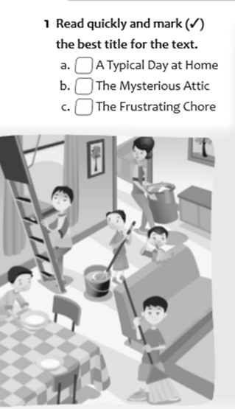
- READING
Remember a time when life was normal.
I was a little boy with four brothers and a loving but strict mother who always asked us to help with the household chores. We all chipped in, and since there were five of us, the workload was never terribly hard.
Jon usually preferred to do the dishes after breakfast. Tony and Frank generally argued regardless of what job they ended up with. Jim usually opted for taking out the trash and separating it into the different recycling bins. preferred making the beds because could always have s quick nap.
The one thing we all heed doing was dusting. It wasn't the hardest of jobs, but it implied moving everything on or around the fumiture to really do it well. In particular, we hated dusting the stuff in the attic. It was dark up there, and used to imagine all sorts of scary things whenever I was up there, like someone —or something— waiting to jump out of the shadows.
One time, after my mother had distributed the to do, my brother Jim started complaining because he had been told to dust the attic. He wanted to exchange his chore, but none of us would do it. Finally, he reluctantly went up the stairs to clean the attic. He decided he would do the dusting in rush, so he could- finish as quickly as possible.
We had not seen or heard Jim for a while when my mother called us all for lunch.
That’s when we noticed that he was missing. Jon said he had heard noises in the attic, but that was more than two hours before we set down for lunch. I thought that was strange; we all did. My mother was silent for a moment, and then she asked me to go up to the attic and tell Jim to come down to have his meal. She tried to sound casual, but I know she was nervous.
I went upstairs and called after Jim.
There was no answer. I had to go up into the attic and, when I did, I saw something that
has remained vividly in my mind as if it happened yesterday. I opened the door to the attic
and I saw …
B. SENTENCES.
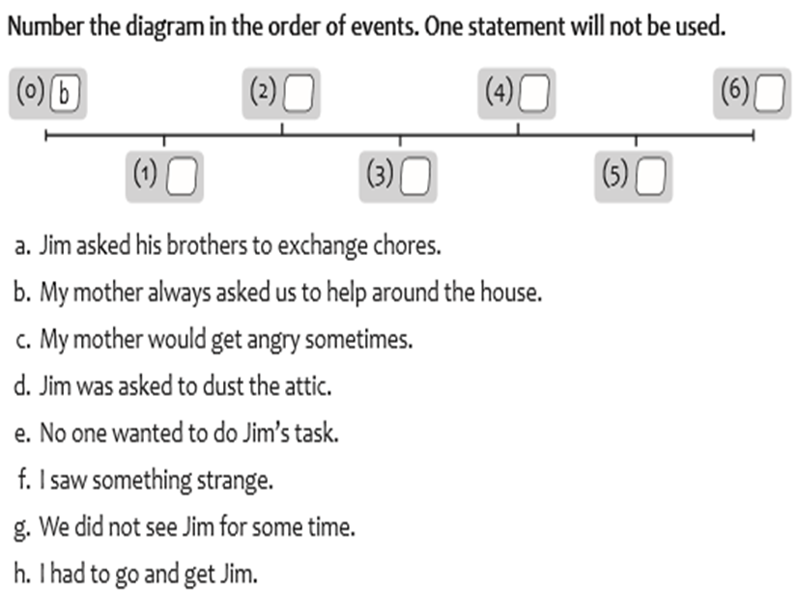

- Jim asked his brothers to exchange chores.
- My mother always asked us to help around the house.
- My mother would get angry sometimes.
- Jim was asked to dust the attic.
- No one wanted to do Jim ‘task.
- I saw something strange.
- We did not see Jim for some time.
- I had to go and get Jim

- DRAW A LINE TO MATCH THE ACTIVITY WITH THE PICTURE.
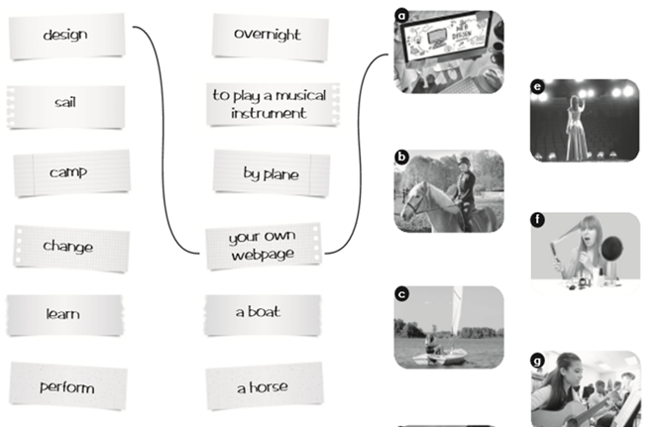
overnight
design
to play musical
instrument
sail
camp
by plane

change
your own
webpage

w
w
learn
a boat
perform
a horse

