COLEGIO EMILIA RIQUELME
AREA DE HUMANIDADES, LENGUA EXTRANJERA

NAME: _______________________________________________________________________________

El siguiente taller consta de (12) puntos, cada uno tiene un valor de (2.0) Recuerda leer con atención cada uno de los enunciados para que respondas adecuadamente.

- READ THE REPORT AND CHOOSE THE CORRECT ANSWER. THEN TRANSLATIONS.
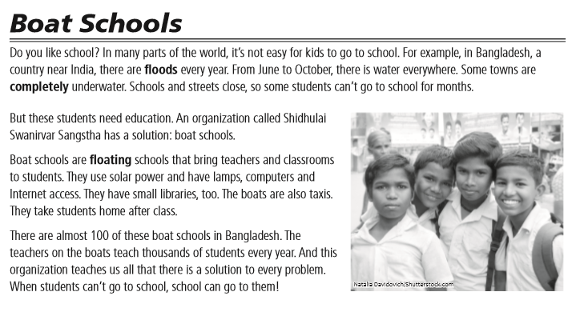

1. There are_______in Bangladesh from June to October. | a. School | b. floods | c. india | d. china
2. Bangladeshis a country near_____. | a. USA | B. china | C. india | d. japan
3. When there are floods, schools and street________. | a. Open | B. Close | c .Behind | d. Near
4. Every student needs a________. | a. Boat | B. Education | c. Money | d. Car
5. Shidhulai Swanirvar Sangstha makes_______. | a. Floating | B. Internet | c. Car | d. Cell
6. The boat schools take students to their_______after class. | A. Libraries | B. Homes | C. School | D. Gym
7.There almost_______boat schools in Bangladesh. | A. 10 | B. 100 | C. 1000 | D. 10.000
8.When students _______get to schools, the schools go to them. | A. Can | B. Can´t | C. Yes | D. Not

B. WRITE 5 RULERS.

C

