
“Ama a Jesús y Él llenará todo tu corazón.”
Beata María Emilia Riquelme

COLEGIO EMILIA RIQUELME
AREA DE HUMANIDADES, LENGUA EXTRANJERA

LEARNING GUIDES AT HOME
GRADE | 9
WEEK | JUNE 8 UNTIL 12/2020
DATE OF DELIVERY | JUNE 12/2020
NAME

TEMA DE LA SEMANA | REVIEW
ACTIVIDADES A REALIZAR | Se realizará un repaso de los temas visto del libro STOPWATCH 4 en el segundo periodo del año.
ACTIVIDADES A REALIZAR | Temas:  HOW MUCH DO YOU REMEMBER? (Unit 5)  HOW CAN WE SAVE THE PLANET? (Unit 3)  (Verbos pasado simple (simple past))
FECHAS ENCUENTRO VIRTUAL (Horario de clase). | Día | Martes 9-06-2020 | Hora | 10:30 a.m.
FECHAS ENCUENTRO VIRTUAL (Horario de clase). | Día | Miércoles 10-06-2020 | Hora | 10:30 a.m.
FECHAS ENCUENTRO VIRTUAL (Horario de clase). | El link de las invitaciones se las enviaré por el grupo del WhatsApp de inglés.
DIA DE ASESORÍA | Todos los viernes de 10:30 a 11:30 a.m. estaré disponible para brindar asesoría, vía WhatsApp, correo electrónico y/o vía telefónica.
NOTA IMPORTANTE | Sí no se pueden comunicar en el horario establecido para la asesoría, estoy disponible para brindarla desde las 3:30 p.m. de lunes a viernes.
DATOS DE CONCTADO DOCENTE SANDRA HEREDIA | Correos electrónicos: |  | zammyhd@gmail.com  sandrac@campus.com.co
DATOS DE CONCTADO DOCENTE SANDRA HEREDIA | WhatsApp grupo noveno

COLEGIO EMILIA RIQUELME
AREA DE HUMANIDADES, LENGUA EXTRANJERA

REVIEW
GRADE | 9
WEEK | JUNE 8 UNTIL 12/2020
DATE OF DELIVERY | JUNE 12/2020
NAME

- FIND AND WRITE THE VERBS TO COMPLETE THE PHRASES.
0. | Conserve water. | 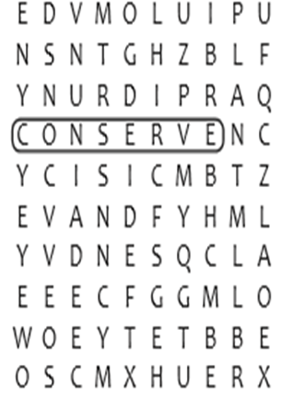
1. | _____________less fossil fuels.
2. | ______________electricity.
3. | ______________trees.
4. | Don’t_______________ garbage to landfills
5. | ____________plastic, glass, metal and paper.

- FIND AND WRITE THE KEEPSAKES.
0. | babytooth | 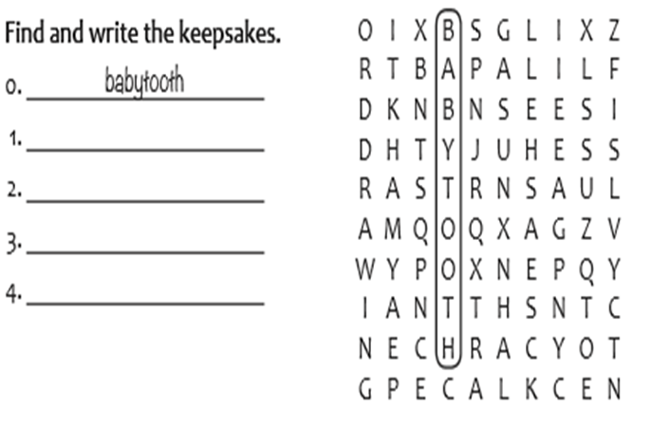
1.
2.
3.
- MATCH THE SENTENCE PARTS.
0. My parents were making dinner when… |  | - We heard a knock at the door.
1.I was doing my homework in my bedroom while… |  | - a string broke.
2.Jaime was working at the corner store while… |  | - listening to music.
3.My aunt was going to work when… |  | - we were reviewing for a test.
4.I was practicing the guitar when… |  | - studying at the university
5. They were painting the school while… |  | - she saw an accident.

D.READ AGAIN AND PUT THE STEPS IN THE CORRECT ORDEN
- Confront opposition with a positive attitude.
- Decide on the goal of the action you will take.
- Discover what your interest is.
- Invite other people to help you if you want.
- Stay motivated.
- Make a list of potencial things you can do.
- Study about a specific environmental topic.

E. READING / TRASLATION.
HOW TO BECOME A GREEN ACTIVIST

People with the determination to speak up and to do things for a cause are called "activists." They work to change things and invite others to join them.

We can all be activists if we choose to be. In the fight to save the Earth, Green Activists are needed all the time.

Start by finding out what your "green" passion is. What do you care more about: Animals? Plants? The ocean?
The air? Start with something specific that really attracts you, because this is something that will be around you for a long time.

After this, read as much as you can about your cause.
Watch videos, read articles and research organizations that support the cause. Then you can decide how much time you want to invest (an hour a week is a good starting point!) and how you want to work: Do you prefer to work alone or with others? Can you join a group?

Next, think about possible actions: Can you ask a teacher for time to discuss your cause with the class? Do you want to post messages in social media? When you choose what to do, make sure to decide on a goal.
Have a clear objective for every action.

The last step to take is to keep the cause going. Find ways to stay motivated because you will find distractions along the way. You will also find people who don't believe in what you are doing. This may be discouraging, but don't stop. You can always say: "This is what I can do now and I hope you can join me."

Always remember that environmental problems were not created in a day and they won't be solved in a day, but if each one of us becomes a Green Activist, the world will surely become a better place!

