


COLEGIO EMILIA RIQUELME
AREA DE HUMANIDADES, LENGUA EXTRANJERA

LEARNING GUIDES AT HOME
GRADE | 6
WEEK | JUNE 8 UNTIL 12/2020
DATE OF DELIVERY | JUNE 12/2020
NAME

TEMA DE LA SEMANA | REVIEW
ACTIVIDADES A REALIZAR | Se realizará un repaso de los temas vistos del libro STOPWATCH 1 en el segundo periodo del año.
ACTIVIDADES A REALIZAR | Temas:  WHAT IS HOME? (Unit 4)  WHAT’S YOUR ROUTINE? (Unit 5)
FECHAS ENCUENTRO VIRTUAL (Horario de clase). | Día | Martes 9-06-2020 |  | Hora | 07:00 a.m.
FECHAS ENCUENTRO VIRTUAL (Horario de clase). | Día | Jueves 11-06-2020 |  | Hora | 10:30 a.m.
FECHAS ENCUENTRO VIRTUAL (Horario de clase). | El link de las invitaciones se las enviaré por el grupo del WhatsApp de inglés.
DIA DE ASESORÍA | Todos los viernes de 9:30 a 10:30 a.m. estaré disponible para brindar asesoría, vía WhatsApp, correo electrónico y/o vía telefónica.
NOTA IMPORTANTE | Sí no se pueden comunicar en el horario establecido para la asesoría, estoy disponible para brindarla desde las 3:30 p.m. de lunes a viernes.
DATOS DE CONCTADO DOCENTE SANDRA HEREDIA | Correos electrónicos: |  | zammyhd@gmail.com  sandrac@campus.com.co
DATOS DE CONCTADO DOCENTE SANDRA HEREDIA | WhatsApp grupo sexto

COLEGIO EMILIA RIQUELME
AREA DE HUMANIDADES, LENGUA EXTRANJERA

REVIEW
GRADE | 6
WEEK | JUNE 8 UNTIL 12/2020
DATE OF DELIVERY | JUNE 12/2020
NAME

- LOOK AND COMPLETE USING ALWAYS, SOMETIMES OR NEVER WRITE THE CORRECT FORM OF THE VERB.

0. | Jesse never (XXXXX) takes a shower at 6:30.(take)
1. | Sherry_____________ (XX///) ____________ junk food.(eat)
2. | Nancy and I _____________ (//XXX)____________ soccer after school.(play)
3. | Joseph _______________(/////)________________ up at six o´clock.(get)
4. | Alex and Jorge ______________(XXXXX)______________ to school at 5 o´clock.(go)
5. | I ________________(/////)________________my bed in he morning.(make)
6. | Mom ______________(XX///)______________groceries during the week.(buy)

- TRASLATIONS.

This is Andre. He’s a morning person.  His favorite time of day is 6 a.m. He is  always happy in the morning. Every  day he wakes up early, exercises and takes a shower. Then he has breakfast with his family and goes to work. | 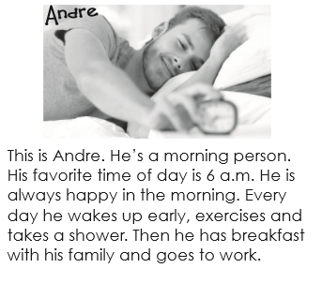

C.CIRCLE THE INCORRECT OBJECT AND COMPLETE THE NAMES.
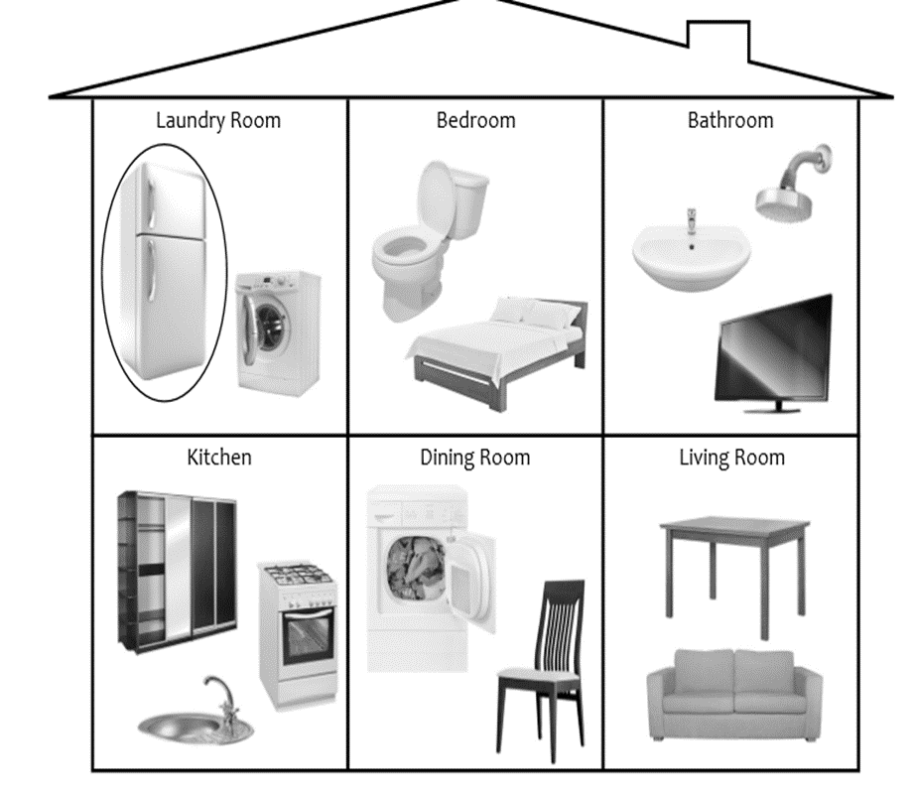

Laundry Room | Bathroom | Dinig Room
w __ashe___r | s________________ r | t____________e
d _____________ r | s________________ k | c____________r
 | t________________ t
Kitchen | Nedroom | Livong Room
r_________r (f______e) | b______d | s____________a
s____________e | c____________t | t__________n(_____V)
s____________k

D.CLASSIFFY HOW YOU FEEL ABOUT THE ACTIVITIES

Dancing cleaningyor room texting playing soccer watching soccer on TV
cooking going to the gym doing homework feeding your pet
eating broccoli going shopping riding the bus playing video games

hate | Like | love

