


COLEGIO EMILIA RIQUELME
AREA DE HUMANIDADES, LENGUA EXTRANJERA

LEARNING GUIDES AT HOME
GRADE | 11
WEEK | JUNE 8 UNTIL 12/2020
DATE OF DELIVERY | JUNE 12/2020
NAME

TEMA DE LA SEMANA | REVIEW
ACTIVIDADES A REALIZAR | Se realizará un repaso de los temas visto del libro STOPWATCH 6 en el segundo periodo del año.
ACTIVIDADES A REALIZAR | Temas:  WHAT ARE YOU LIKE? (Unit 1)  WHAT WOULD THE WORLD BE LIKE IF…? (Unit 6)
FECHAS ENCUENTRO VIRTUAL (Horario de clase). | Día | Martes 9-06-2020 |  | Hora | 01:00 p.m.
FECHAS ENCUENTRO VIRTUAL (Horario de clase). | Día | Jueves 11-06-2020 |  | Hora | 07:00 a.m.
FECHAS ENCUENTRO VIRTUAL (Horario de clase). | El link de las invitaciones se las enviaré por el grupo del WhatsApp de inglés.
DIA DE ASESORÍA | Todos los jueves de 07:00 a 08:00 a.m. estaré disponible para brindar asesoría, vía WhatsApp, correo electrónico y/o vía telefónica.
NOTA IMPORTANTE | Sí no se pueden comunicar en el horario establecido para la asesoría, estoy disponible para brindarla desde las 3:30 p.m. de lunes a viernes.
DATOS DE CONCTADO DOCENTE SANDRA HEREDIA | Correos electrónicos: |  | zammyhd@gmail.com  sandrac@campus.com.co
DATOS DE CONCTADO DOCENTE SANDRA HEREDIA | WhatsApp grupo once

COLEGIO EMILIA RIQUELME
AREA DE HUMANIDADES, LENGUA EXTRANJERA

REVIEW
GRADE | 11
WEEK | JUNE 8 UNTIL 12/2020
DATE OF DELIVERY | JUNE 12/2020
NAME

- COMPLETE SENTENCES.
Breakthrough crisis disaster discovery pandemic revolution war

- When a disease spreads through a whole country, continent or the world it’s
called a pandemic.

- If country’s economy is in trouble it is having an economic__________________.

- When an earthquake suddenly hits a city and causes destruction it is considered
a natural _______________________.

- When a scientist finds a new cure to a disease she makes a____________________.

- An armed conflict between more than one nation or group is called a ______________.

- When you finally find an answer to a difficult problem, we say you achieve a_________________.

- When the people go against their government to change it they start a _____________.

- COMPLETE THE DIALOGUE WITH TAG QUESTIONS.
Roommate wanted, two bedroom.  One bath apartment, near the  University, $350 month+utilities,  Included, must not be allergic  To cats (I have one), laundry  Facilities on site, walking distance  To shopping and transportation,  No smoking. Call 278-6799. | 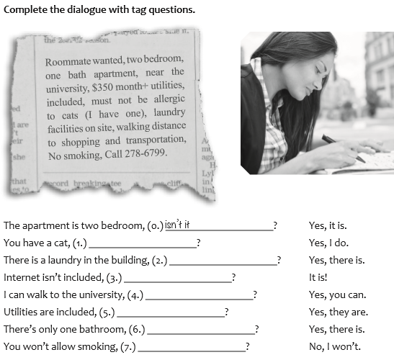

The apartment is two bedroom, (o.) isn’t? Yes, it is.
You have a cat, (1.) __________________? Yes, I do.
There is a laundry in the building, (2.) ______________? Yes, there is.
Internet isn´t included, (3.) _______________________? It is?
I can walk to the university, (4.) ____________________? Yes, you can.
Utilities are included, (5.) ___________________________? Yes, they are.
There’s only one bathroom, (6.) ______________________? Yes, there is.
You won’t allow smoking, (7.)_________________________? No, I won’t

C. READING, COMPREHETION AND TRASLATION.

San Andreas and the Reality of a Threat

Natural disasters are all catastrophic events caused by environmental factors. It is almost impossible to predict when they will strike and how strong they might be; that is why they are considered a threat to humankind and life as we know it. As rational beings, we understand how inevitable natural phenomena are, so we do our best to leam what causes them and how
to be prepared to avoid being hurt.

The State of California is located between two major tectonic plates moving in contrasting directions. This causes different cuts or faults that extend to very deep levels under the ground, and the San Andreas Fault is probably the biggest and most dangerous one. This geologic gash is about 1,300 km long.

The existing faults cause the State of California to be susceptible to earthquakes. Historical records show there have been major ones every 110 to 140 years. In 1906 there was a catastrophic earthquake in San Francisco with an estimated magnitude of 7.8 and that was attributed to the San Andreas Fault.

Seismologists study the fault trying to predict when the next "Big One" will happen. The Smithsonian website explains that, if the "Big One" happened these days, the reality would not look anything like what Hollywood may have shown in movies. There wouldn't be a tsunami, for example.

However, they say, its impact would still be devastating: such an event "would cause some $200 billion in damage, 50,000 injuries and 2, 000 deaths." The real damage would come after the earthquake: there would be fires, water supplies would run out and all services would be damaged.

The US geological service anticipates only a 7 percent probability of a major earthquake in California in the next 30 years, so there is no cause for immediate alarm. However, experts recommend preparing because the earthquake will happen. While there is no point in living with fear, knowing what can happen and exactly what to do can save countless lives.

- We study natural phenomena to be ready for/stop them.
- The San Andres Fault was caused by dirt/movement in the tectonic plates.
- California is a state where big earthquakes can/cannot happen.
- The “Big One” is how people refer to an earthquake/a tsunami in San Francisco.
- The next earthquake will have terrible/insignificant consequences.
- Besides getting ready, people in California should get informed/afraid before the “Big One.”

