
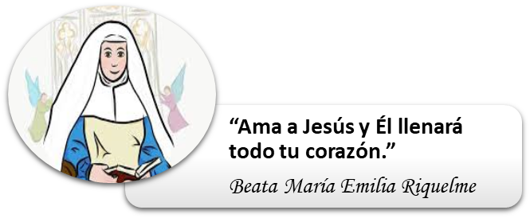

COLEGIO EMILIA RIQUELME
AREA DE HUMANIDADES, LENGUA EXTRANJERA

LEARNING GUIDES AT HOME
GRADE | 8
WEEK | JUNE 8 UNTIL 12/2020
DATE OF DELIVERY | JUNE 12/2020
NAME

TEMA DE LA SEMANA | REVIEW
ACTIVIDADES A REALIZAR | Se realizará un repaso de los temas visto del libro STOPWATCH 3 en el segundo periodo del año.
ACTIVIDADES A REALIZAR | Temas:  WHAT DOES IT MEAN TO BE HAPPY? (Unit 5)  HOW DO YOU FEEL? (Unit 8)  (Verbo to be Was –Were – pasado – simple past)
FECHAS ENCUENTRO VIRTUAL (Horario de clase). | Día | Lunes 8-06-2020 | Hora | 01:00 p.m.
FECHAS ENCUENTRO VIRTUAL (Horario de clase). | Día | Miércoles 10-06-2020 | Hora | 07:00 a.m.
FECHAS ENCUENTRO VIRTUAL (Horario de clase). | El link de las invitaciones se las enviaré por el grupo del WhatsApp de inglés.
DIA DE ASESORÍA | Todos los viernes de 01:00 a 02:00 p.m. estaré disponible para brindar asesoría, vía WhatsApp, correo electrónico y/o vía telefónica.
NOTA IMPORTANTE | Sí no se pueden comunicar en el horario establecido para la asesoría, estoy disponible para brindarla desde las 3:30 p.m. de lunes a viernes.
DATOS DE CONCTADO DOCENTE SANDRA HEREDIA | Correos electrónicos: |  | zammyhd@gmail.com  sandrac@campus.com.co
DATOS DE CONCTADO DOCENTE SANDRA HEREDIA | WhatsApp grupo octavo

COLEGIO EMILIA RIQUELME
AREA DE HUMANIDADES, LENGUA EXTRANJERA

REVIEW
GRADE | 8
WEEK | JUNE 8 UNTIL 12/2020
DATE OF DELIVERY | JUNE 12/2020
NAME

- LOOK AND COMPLETE.
Un the back nex to in the middle
inside in the front on the right

I love to visit my grandparents. This is a picture of their  house. There is a yard in the front of the  House and a big tree_______________. The front  Door is __________________and there are two  Bushes _________________ it. On the left there  Are four windows and _______________there  Are only two. __________________And best of all,  ___________________it’s always cozy and warm. | 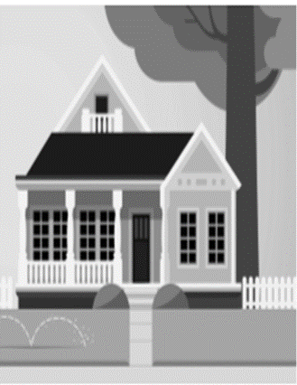

B. CIRCLE THE CORRECT OPTIONS.

o. My friends was/were at the mall last weekend.
1. Jay was / were late for P.E. this morning.
2. We wasn't / weren't home last week.
3. Was / Were you in math class Tuesday?

4. How many people was/were at your volleyball game last night?
5. My aunt wasn't / weren't happy with her birthday present last year.
6. I wasn't / weren't in the photography club last year.

C. READING / TRASLTION.

FRIENDSHIP AND HAPPINESS

Human beings are built for connection. When we are
born, we are helpless. We need our mothers, fathers
and caregivers to stay alive. We need connection to love.
So It's not surprising that scientists have evidence that
friendship —a good connection with someone— can help us be happy and healthy.
Two scientists did a study about the power of social
networks. They found that happiness Is contagious
among friends. They learned that our happiness can
make our friends and their friends happy. That's a lot
of happy connections!

Other scientists found that our friends' support can help
us stay healthy. It's easier to start and continue good
habits with friends. It’s also easier to quit bad habits with a friend’s support. Even more studies show that having friends can help us live longer!

Now we know that friends and friendships can make us
feel good. But how do we make friends? Another group
of scientists have a possible answer. These scientists did
experiments with pairs of strangers. The pairs answered
36 personal questions, shared stories and made eye
contact. And they often made great friendships
and connections!

0. | People are made for... | a. scientists. | b. connection. | c. questions.
1. | Without connection, _________can’t survive. | a. babies | b. support | c. happiness
2. | There is evidence that__________ can make us happy. | a. stranger | b. experiments | c. friendships
3. | One study shows that happiness is... | a. contagious. | b. questions. | c. science.
4. | It is easier to start good with________ friends. | a. friends | b. habits | c. answers
5. | __________bad habits is easier with the support of friends. | a. Studying | b. Quitting | c. Starting
6. | Maybe we can make__________ by sharing personal stories. | a. connection | b. eye contact | c. friends

