COLEGIO EMILIA RIQUELME
AREA DE HUMANIDADES, LENGUA EXTRANJERA

NAME: __________________________________________________________________________

El siguiente taller consta de (6) puntos, cada uno tiene un valor de (0.34) Recuerda leer con atención
cada uno de los enunciados para que respondas adecuadamente.

A. READ THE TEXT ANSWER AND TRASLATION.
B. DESCREBE YOUR FAVORITE SPORT

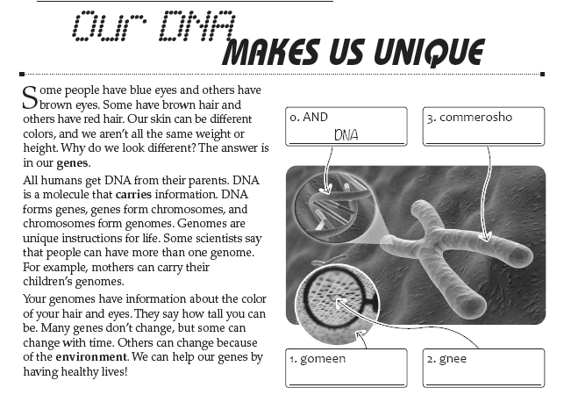

5. Having a healthy life can help your genes. | a. True | b. False | c. Don’t say | d. say
6. Everyone has the same skin color. | a. True | b. False | c. Don’t say | d. say
7. A person´s height can come from their DNA. | a. True | b. False | c. Don’t say | d. say
8. All people get DNA from their friends. | a. True | b. False | c. Don’t say | d. say
9. Genomes are likes instructions for life. | a. True | b. False | c. Don’t say | d. say
10. Genomas don´t carry informations for life. | a. True | b. False | c. Don’t say | d. say

