Unit 1 Vocabulary Worksheet 2

Name
Family Relationships 2

Classify the family words.
aunt brother cousin father (dad) grandmother (grandma) grandfather (grandpa) grandparents mother (mom) niece nephew parents sister uncle

Male | Both | Female
father (dad)

- Read and complete the family tree.
  - Rebecca is Emily and Danny’s cousin.
  - Fred and Harriet are the grandparents of Emily, Danny and Rebecca.
  - Danny is Jean and Alan’s nephew.
  - Jean is Tom’s sister, and the aunt of Emily and Danny.
  - Emily is Jean and Alan’s niece.
  - 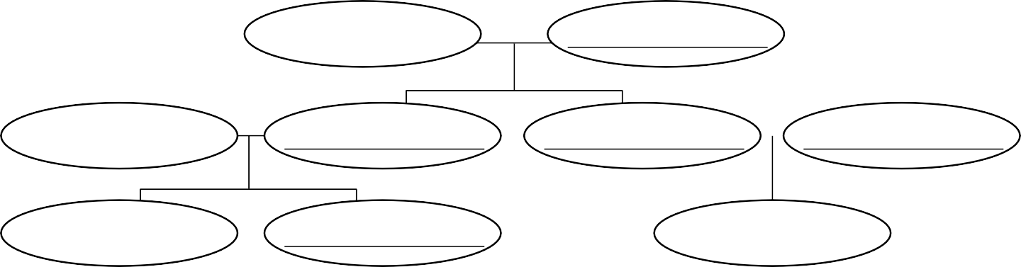Tom is Rebecca’s uncle.
Fred
Marcia
Emily
Rebecca

Complete the sentences with the correct family words.
  - Rebecca is the daughter of Tom’s sister. She is his niece .
  - Danny is the son of Jean’s brother. He is her .
  - Fred is Emily and Danny’s grandfather and Tom’s .
  - Harriet is Rebecca’s grandmother and Jean’s .
  - Rebecca is Tom’s niece. Tom is her .
  - Danny is Jean’s nephew. Jean is his .
1 D.R. © Richmond Publishing, S.A. de C.V., 2016 Photocopiable

1.1.V2

