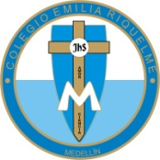
GRADE: | 6
DATE: | 20-03-2020
WORKSHOP | 1

COLEGIO EMILIA RIQUELME
AREA DE HUMANIDADES, LENGUA EXTRANJERA

NAME: _______________________________________________________________________________

El siguiente taller consta de (15) puntos, cada uno tiene un valor de (2.0) Recuerda leer con atención
cada uno de los enunciados para que respondas adecuadamente.

A. READ THE TEXT: ANSWER AND TRANSLATION.

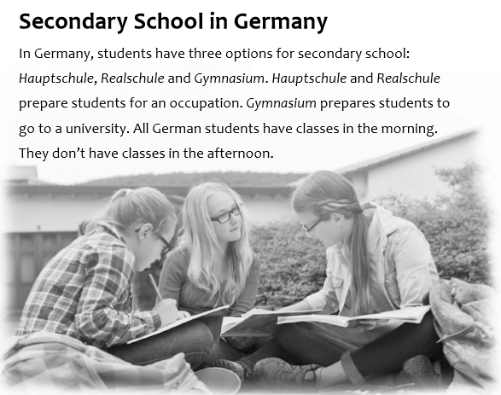

B. LOOK THE FAMILY AND ANSWER THE CORRECT OPTION.
1. Germany has three types of secondary school | a. True | b. False | c. say | d. Don’t say
2. After Realschule, students go to a university | a. True | b. False | c. say | d. Don’t say
3. Students in gymnasium only have P.E. classes | a. True | b. False | c. say | d. Don’t say
4. German students don’t have class in the morning | a. True | b. False | c. say | d. Don’t say
5. They have classes in the afternoon | a. True | b. False | c. say | d. Don’t say
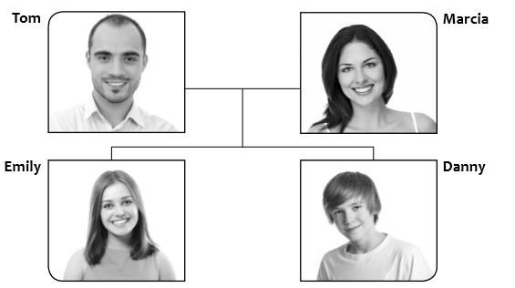

6. Emily is Danny’s: | a. Brother | b. sister | c. Mother | d. Me
7. Danny is Emily’s: | a. Brother | B. Father | C. Son | d. Me
8. Marcia is Emily and Danny’s: | a. Mother | B. Parents | c .Me | d. Son
9. Tom is Emily and Danny’s: | a. Parents | B. Father | c. Son | d. Me
10. Danny is Tom and Marcia’s: | a. Son | B. Father | c. Me | d. Mother

C. CIRCLE THE NUMBER WORDS IN THE PUZZLE AND WRITE THEM.

